1. Could not find build.properies or gradle.properties in apktool generated folder. Found these lines in manifest:

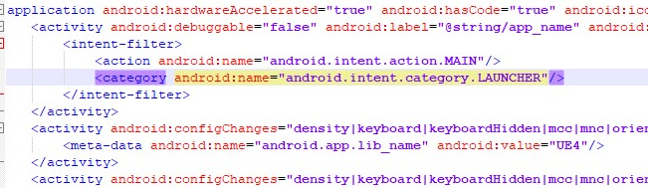

android:debuggable is false, so I suppose that means everything’s okay here.

1. During investigation of strings.xml I found these lines:

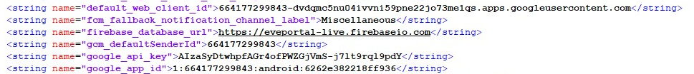

Maybe default ids can be used to access some data? Also, google_api_key can also be used to make some calls to google api to extract data?

1. In AndroidManifest.xml I found permissions:

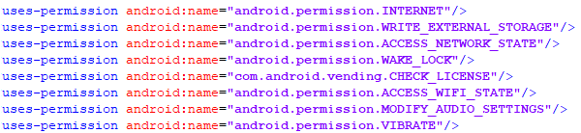

1. When I unpacked .dex to jar I found this structure of packages:

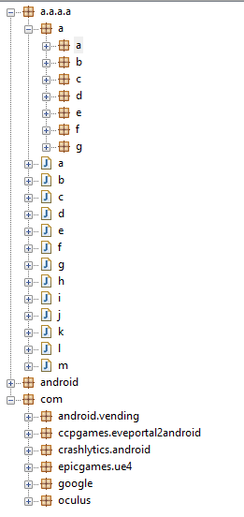

What this a, b, c classes and packages mean I have no idea. Maybe there were some errors during extraction?

Could not find any MODE_WORLD_READABLE or MODE_WORLD_WRITABLE flags.

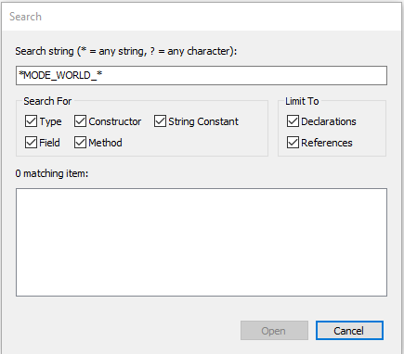

1. Searched for SharedPreferences:

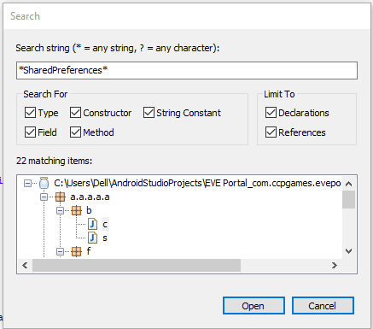

Most usages are just for some app info, like:

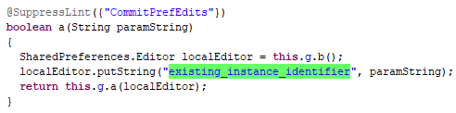

Though I found out that they wrote their own storage for info (based on SharedPreference probably):

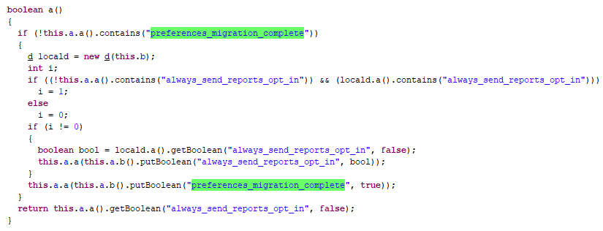

But as I looked through its usages I didn’t find anything suspicious like secret_key or anything, mostly they were putting some boolean flags and ids into this storage.

1. Searched for File(Input|Output)Stream:

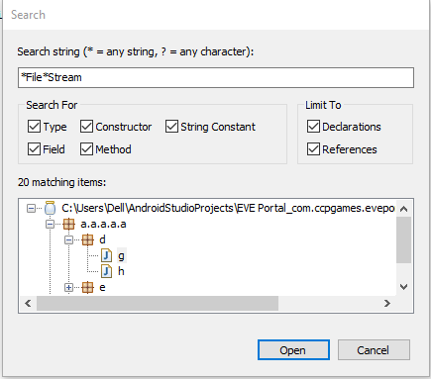

I didn’t notice any code that would lead to writing sensitive data to files, mostly it was analytics logs, but some functions were not converted, so I can’t be sure right there:

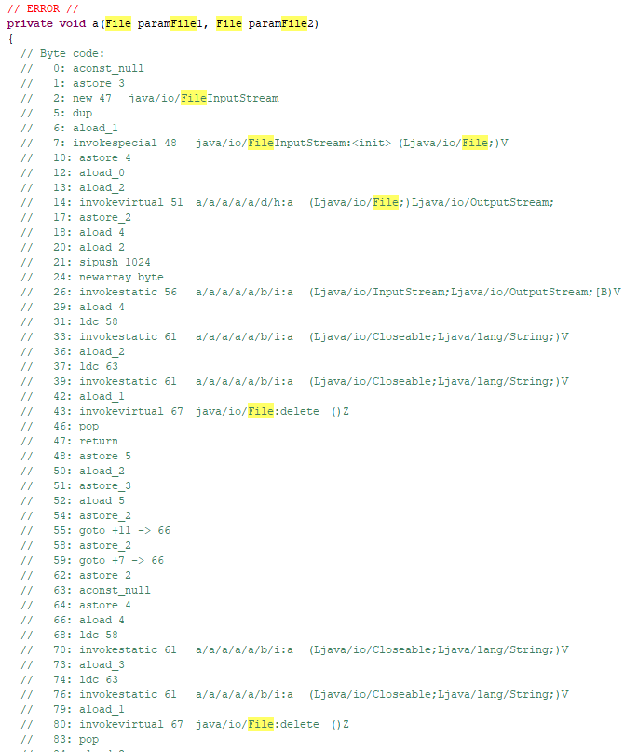

1. During lookup of External stuff I found this:

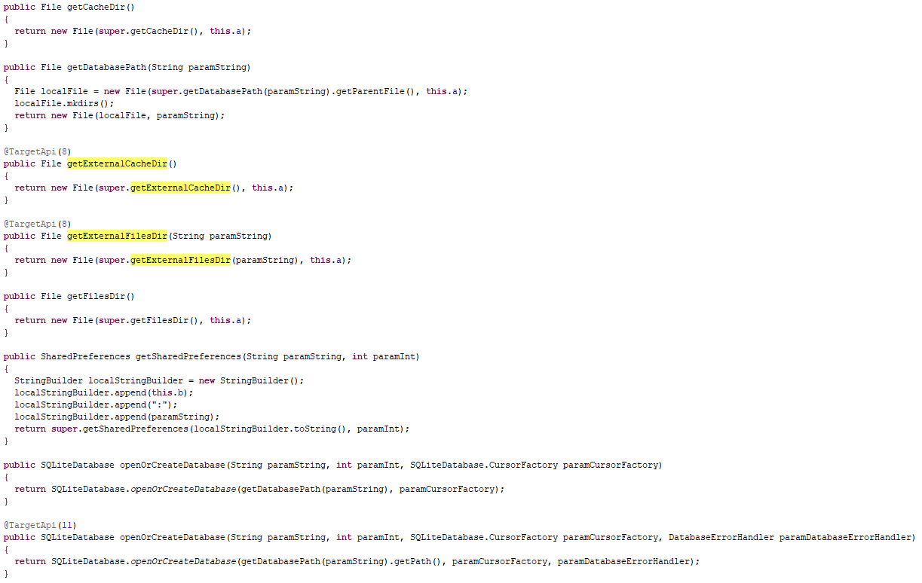

Here we can see initialization of all types of storage: cache, sharedPreferences and database, but I could not completely see where this is used. When I tried searching all code for this functions, there were no matches.